Name: Yash Shah
Batch: D
UID: 2018130049

CEL 51, DCCN, Monsoon 2020
Lab 2: Basic Network Utilities

This lab introduces some basic network monitoring/analysis tools. There are a few exercises along the way. You should write up answers to the ping and traceroute exercises and turn them in next lab. (You should try out each tool, whether it is needed for an exercise or not!).

Prerequisite: Basic understanding of command line utilities of Linux Operating system.

Some Basic command line Networking utilities

Start with a few of the most basic command line tools. These commands are available on Unix, including Linux (and the first two, at least, are also for Windows). Some parameters or options might differ on different operating systems. Remember that you can use man <command> to get information about a command and its options.

ifconfig — You used ifconfig in the previous lab. When used with no parameters, ifconfig reports some information about the computer's network interfaces. This usually includes lo which stands for localhost; it can be used for communication between programs running on the same computer. Linux often has an interface named eth0, which is the first ethernet card. The information is different on Mac OS and Linux, but includes the IP or "inet" address and ethernet or "hardware" address for an ethernet card. On Linux, you get the number of packets received (RX) and sent (TX), as well as the number of bytes transmitted and received. (A better place to monitor network bytes on our Linux computers is in the GUI program System Monitor, if it is installed!!!.)

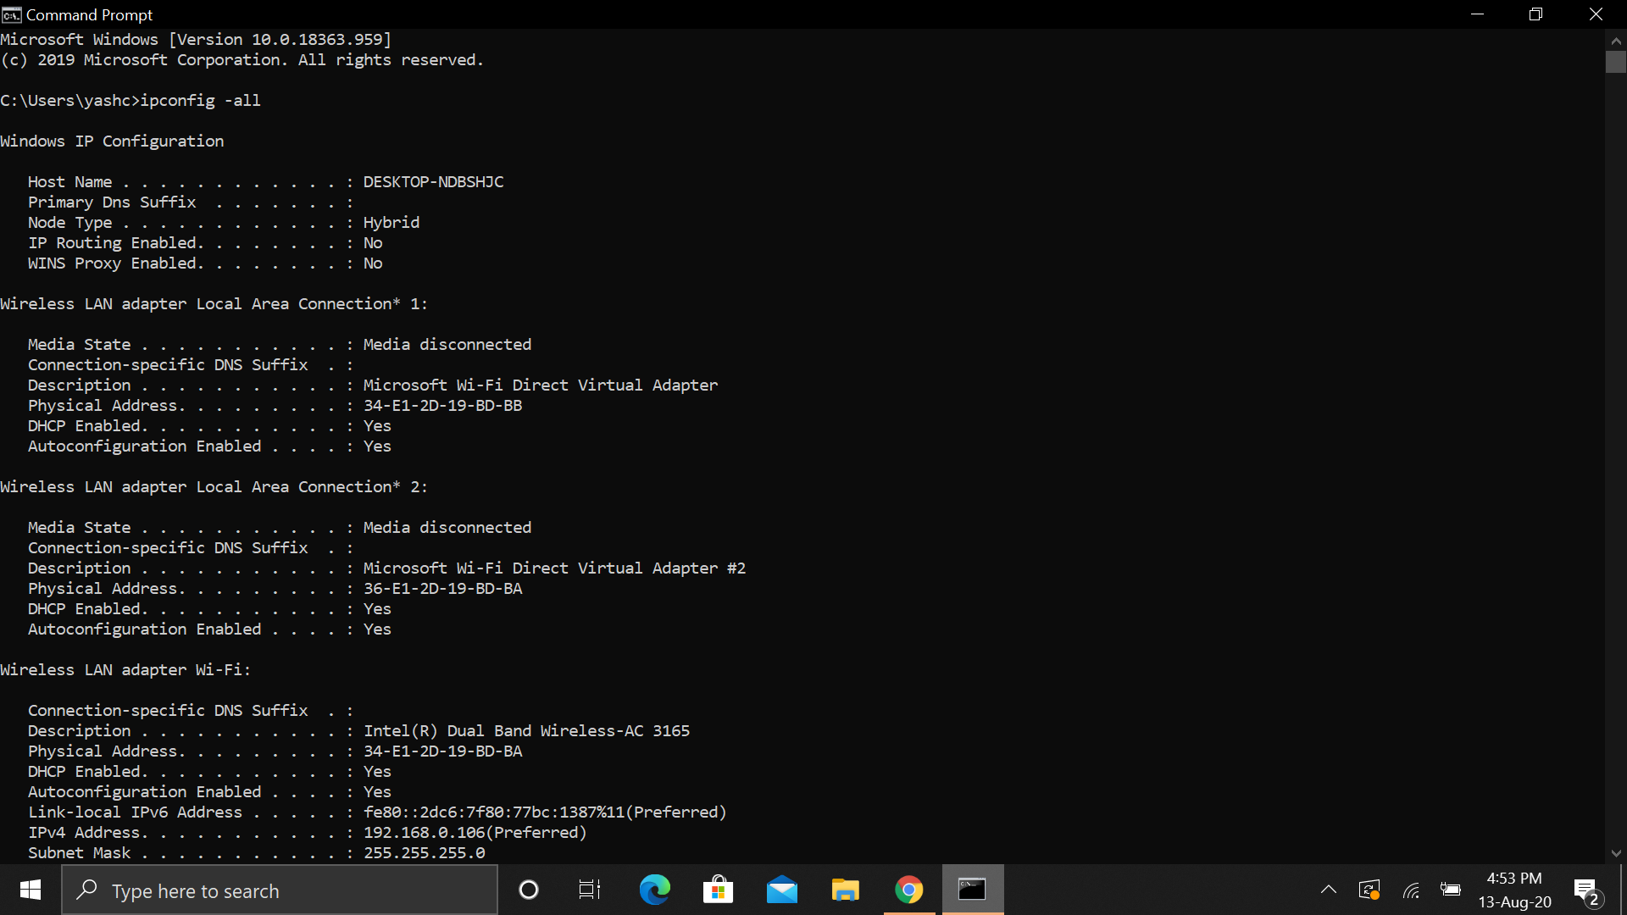

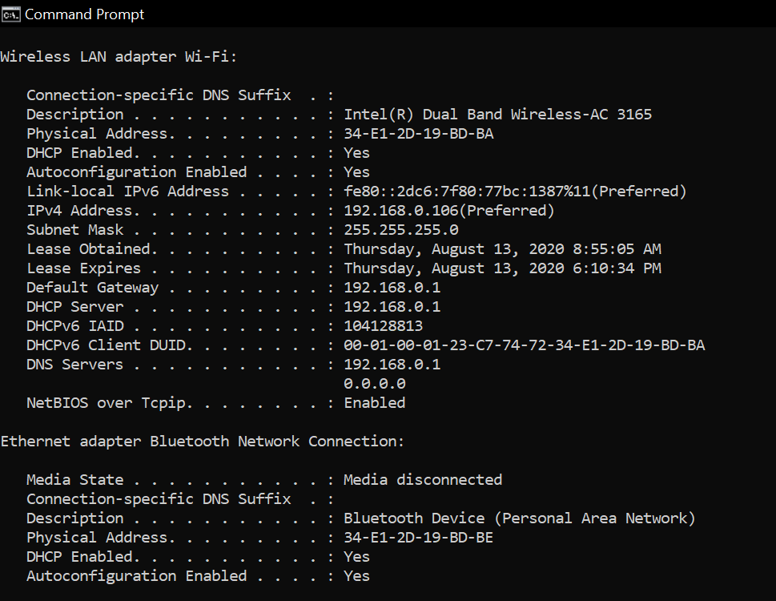

Experiment 0: Experiment with ifconfig and write details about the information returned.

- lo is a special virtual network interface called loopback device. Loopback is used mainly for diagnostics and troubleshooting, and to connect to services running on local host.
- gif0 is Software Network Interface
- stf0 is 6to4 tunnel interface
- en0 is a physical interface representing Ethernet network card. It’s used for communication with other computers on the network and on the Internet.
- Ether is the MAC address which is globally unique.

- mtu stands for Maximum Transmission Units is the size of each packet received by the ethernet card. The value of MTU is set to 1500 by default. The loopback device has a higher MTU value than the ethernet device
- INET 192.168.0.100 is the ipv4 address
- INET6 is the ipv6 address.
- bridge0 is a software bridge between other interfaces
- p2p0 is a point to point interface for wireless services.

FLAGS:
- UP indicates that kernel modules related to the interface have been loaded and interface is activated.
- BROADCAST indicates that interface is configured to handle broadcast packets, which is required for obtaining IP address via DHCP.
- RUNNING indicates that interface is ready to accept data.
- MULTICAST indicates that interface supports multicasting.

ping — The command ping <host> sends a series of packets and expects to receieve a response to each packet. When a return packet is received, ping reports the round trip time (the time between sending the packet and receiving the response). Some routers and firewalls block ping requests, so you might get no reponse at all. Ping can be used to check whether a computer is up and running, to measure network delay time, and to check for dropped packets indicating network congestion. Note that <host> can be either a domain name or an IP address. By default, ping will send a packet every second indefinitely; stop it with Control-C

Network latency, specifically round trip time (RTT), can be measured using ping, which sends ICMP packets. The syntax for the command in Linux or Mac OS is:
ping [-c <count>] [-s <packetsize>] <hostname>

The syntax in Windows is:

ping [-n <count>] [-l <packetsize>] <hostname>

The default number of ICMP packets to send is either infinite (in Linux and Mac OS) or 4 (in Windows). The default packet size is either 64 bytes (in Linux) or 32 bytes (in Windows). You can specify either a hostname (e.g., spit.ac.in) or an IP address.

To save the output from ping to a file, include a greater than symbol and a file name at the end of the command. For example:
ping -c 10 google.com > ping_c10_s64_google.log

Experiments with Ping
- Ping the any hosts 10 times (i.e., packet count is 10) with a packet size of 64 bytes, 100 bytes, 500 bytes, 1000 bytes, 1400 bytes
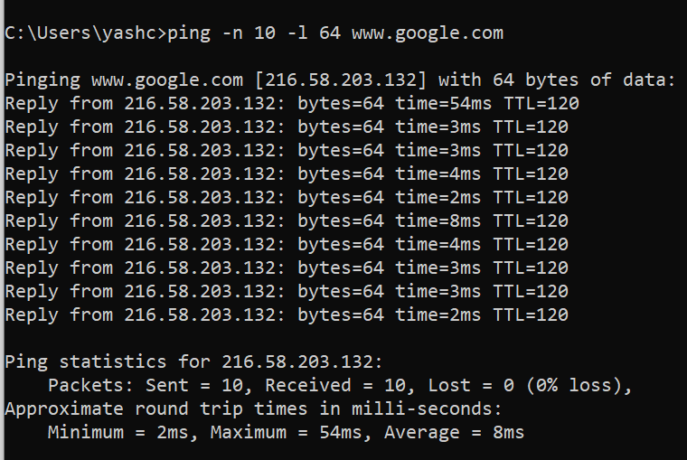
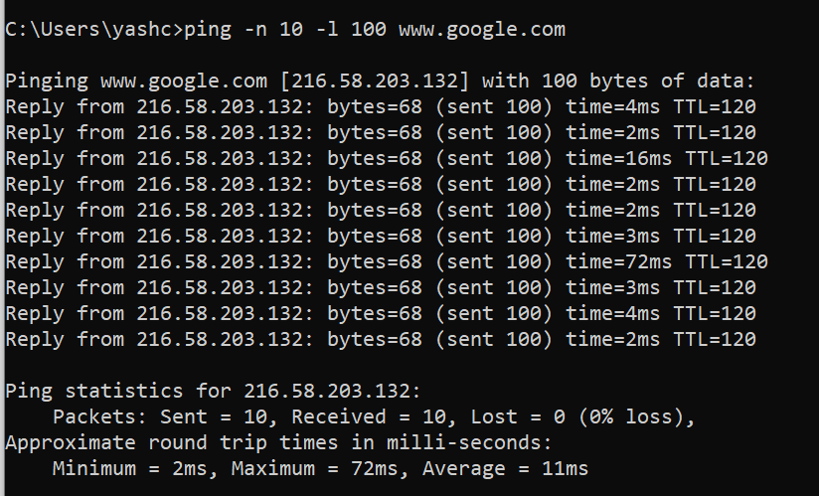

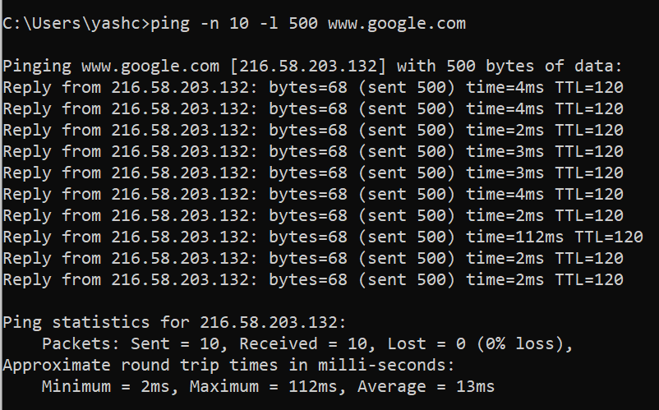

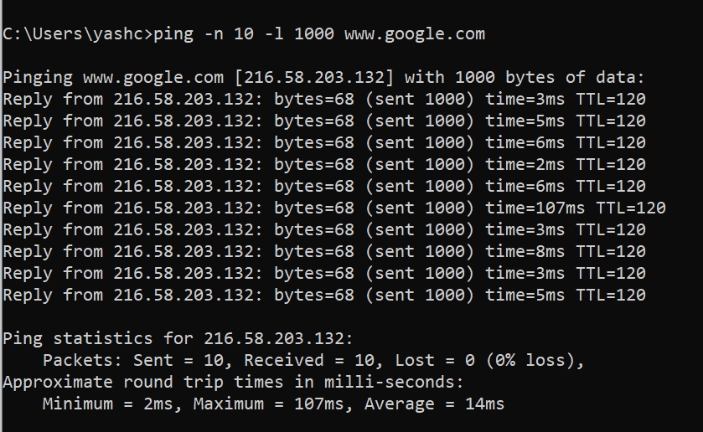

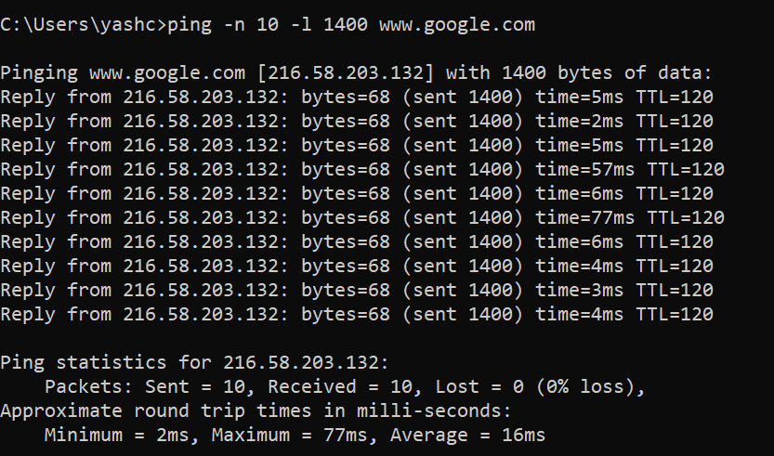

Questions About Latency
Now look at the results you gathered and answer the following questions about latency. Store your answers in a file named ping.txt.
- Does the average RTT vary between different hosts? What aspects of latency (transmit, propagation, and queueing delay) might impact this and why?
Ans.
Round-trip time (RTT) is the duration in milliseconds (ms) it takes for a network request to go from a starting point to a destination and back again to the starting point. RTT is an important metric in determining the health of a connection on a local network or the larger Internet, and is commonly utilised by network administrators to diagnose the speed and reliability of network connections. Round Trip Time is the time it takes for a network request to go from a starting point to a destination and back again.

Transmit delay - time it takes to push the packet's bits onto the link depends on size of the packet and the bandwidth of the network.
Propagation delay - time it takes a router to process the packet header, depends on the processing speed of the switch.
Queueing delay - time the packet spends in routing queues depends on the number of packets, size of the packet and bandwidth.
Yes it does vary between different hosts due to queueing delay or due to propagation delay as it depends on a distance.

- Does the average RTT vary with different packet sizes? What aspects of latency (transmit, propagation, and queueing delay) might impact this and why?
Ans. The Transmit delay and Queueing delay both depends on packet sizes and increases if packet sizes increases. Hence average RTT also increases.
Exercise 1: Experiment with ping to find the round trip times to a variety of destinations. Write up any interesting observations, including in particular how the round trip time compares to the physical distance. Here are few places from who to get replies: www.uw.edu, www.cornell.edu, berkeley.edu, www.uchicago.edu, www.ox.ac.uk (England), www.u-tokyo.ac.jp (Japan).
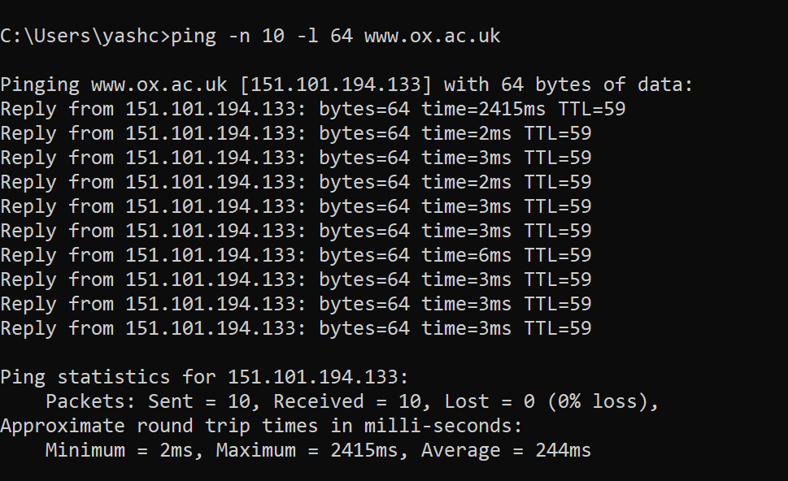
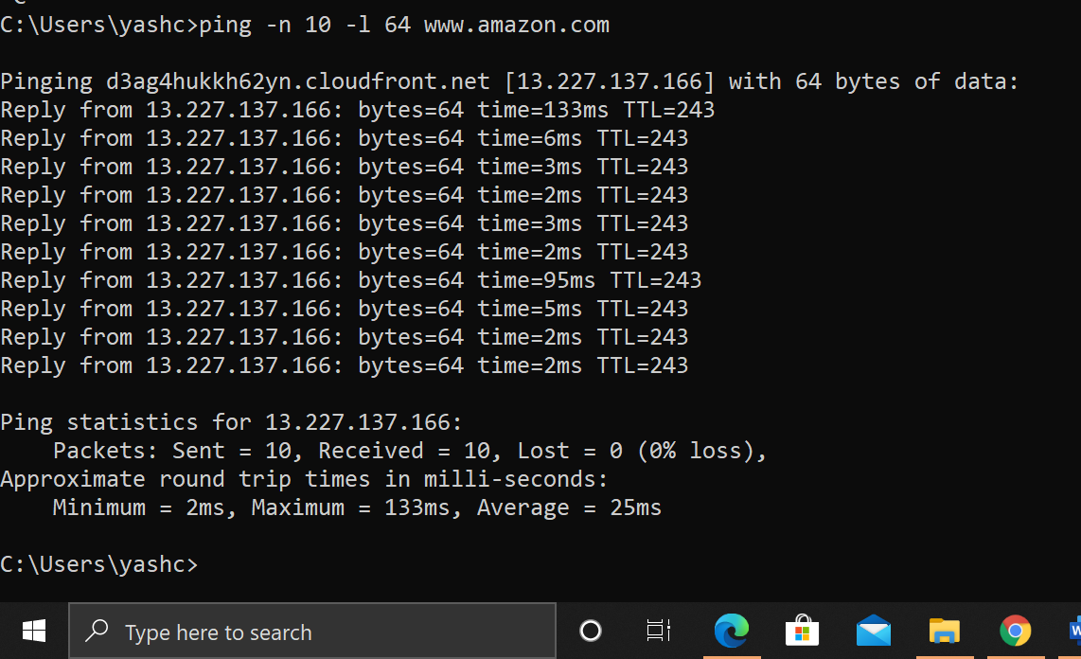
For the same packet sizes, the RTT still varies for different destination. There are few reasons for this:
Physical distance – Physical distance between two hosts is defined as the length of the great circle arc connecting their locations on the surface of the Earth. The sum of per-hop distances would not significantly diverge from the actual distance between hosts.
Nature of the transmission medium - the way in which connections are made affects how fast the connection moves; connections made over optical fiber will behave differently than connections made over copper. Likewise, a connection made over a wireless frequency will behave differently than that of a satellite communication.

Server response time – the amount of time it takes a server to process and respond to a request is a potential bottleneck in network latency. When a server is overwhelmed with requests, such as during a DDoS attack, its ability to respond efficiently can be inhibited, resulting in increased RTT.

Node Count and congestion – depending on the path that a connection takes across the Internet, it may be routed or “hop” through a different number of intermediate nodes. Generally speaking, the greater the number of nodes a connection touches the slower it will be. A node may also experience network congestion from other network traffic, which will slow down the connection and increase RTT.

nslookup — The command nslookup <host> will do a DNS query to find and report the IP address (or addresses) for a domain name or the domain name corresponding to an IP address. To do this, it contacts a "DNS server." Default DNS servers are part of a computer's network configuration. (For a static IP address in Linux, they are configured in the file /etc/network/interfaces that you encountered in the last lab.) You can specify a different DNS server to be used by nslokup by adding the server name or IP address to the command: nslookup <host> <server>

netstat — The netstat command gives information about network connections. I often use netstat -t -n which lists currently open TCP connections (that's the "-t" option) by IP address rather than domain name (that's the "-n" option). Add the option "-l" (lower case ell) to list listening sockets, that is sockets that have been opened by server programs to wait for connection requests from clients: netstat -t -n -l. (On Mac, use netstat -p tcp to list tcp connections, and add "-a" to include listening sockets in the list.)

telnet — Telnet is an old program for remote login. It's not used so much for that any more, since it has no security features. But basically, all it does is open a connection to a server and allow server and client to send lines of plain text to each other. It can be used to check that it's possible to connect to a server and, if the server communicates in plain text, even to interact with the server by hand. Since the Web uses a plain text protocol, you can use telnet to connect to a web client and play the part of the web browser. I will suggest that you to do this with your own web server when you write it, but you might want to try it now. When you use telnet in this way, you need to specify both the host and the port number to which you want to connect: telent <host> <port>. For example, to connect to the web server on www.spit.ac.in: telnet spit.ac.in 80

traceroute — Traceroute is discussed in man utility. The command traceroute <host> will show routers encountered by packets on their way from your computer to a specified <host>. For each n = 1, 2, 3,..., traceroute sends a packet with "time-to-live" (ttl) equal to n. Every time a router forwards a packet, it decreases the ttl of the packet by one. If the ttl drops to zero, the router discards the packet and sends an error message back to the sender of the packet. (Again, as with ping, the packets might be blocked or might not even be sent, so that the error messages will never be received.) The sender gets the identity of the router from the source of the error message. Traceroute will send packets until n reaches some set upper bound or until a packet actually gets through to the destination. It actually does this three times for each n. In this way, it identifies routers that are one step, two steps, three steps, ... away from the source computer. A packet for which no response is received is indicated in the output as a *.

Traceroute is installed on the computers. If was not installed in your virtual server last week, but you can install it with the command sudo apt-get install traceroute

The path taken through a network, can be measured using traceroute. The syntax for the command in Linux is:
traceroute <hostname>

The syntax in Windows is:

tracert <hostname>

You can specify either a hostname (e.g., cs.iitb.ac.in) or an IP address (e.g., 128.105.2.6).

Hop Number – This is the first column and is simply the number of the hop along the route. In this case, it is the tenth hop.

RTT Columns – The next three columns display the round trip time (RTT) for your packet to reach that point and return to your computer. This is listed in milliseconds.
There are three columns because the traceroute sends three separate signal packets. This is to display consistency, or a lack thereof, in the route.

Domain/IP column – The last column has the IP address of the router. If it is available, the domain name will also be listed.

1.2.1 Experiments with Traceroute
From your machine traceroute to the following hosts:
- ee.iitb.ac.in
- mscs.mu.edu
- www.cs.grinnell.edu
- csail.mit.edu
- cs.stanford.edu
- cs.manchester.ac.uk
Store the output of each traceroute command in a separate file named traceroute_HOSTNAME.log, replacing HOSTNAME with the hostname for end-host you pinged
(e.g., traceroute_ee.iitb.ac.in.log).

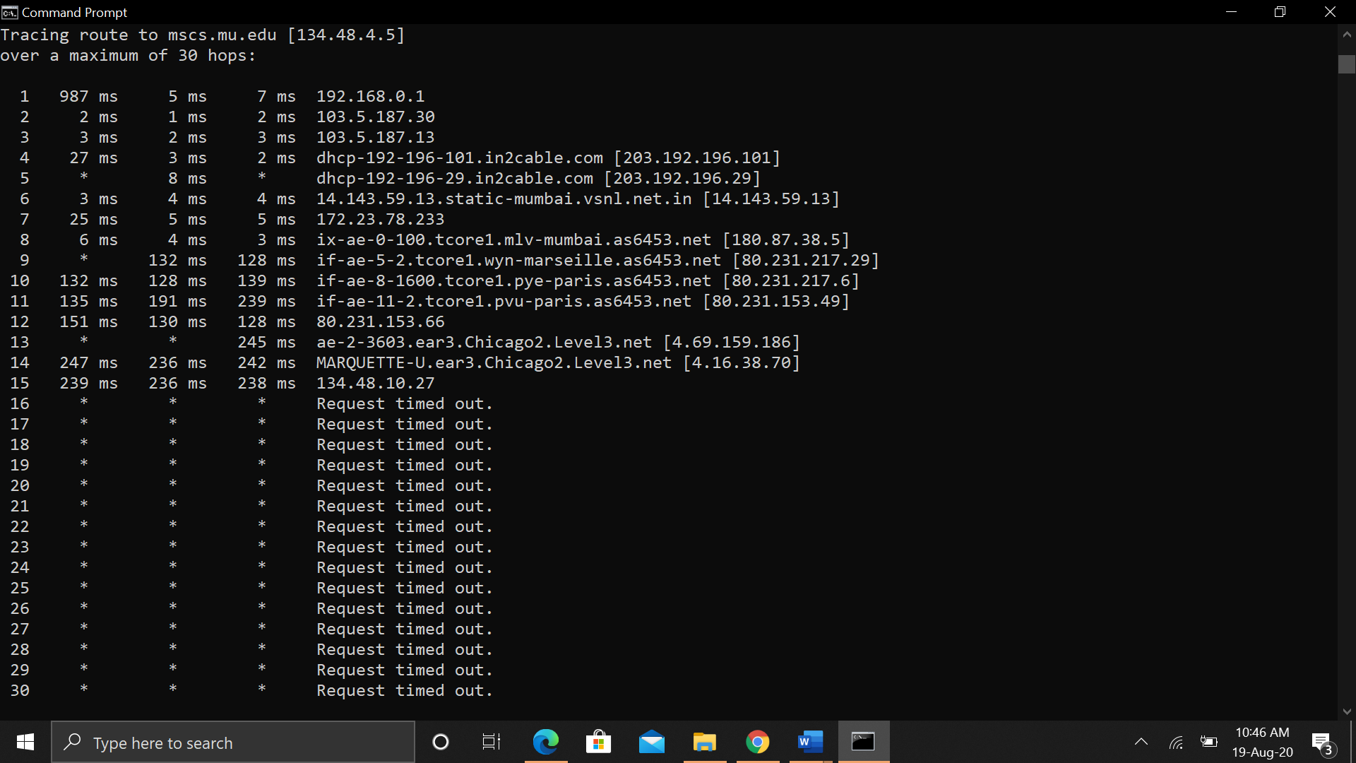

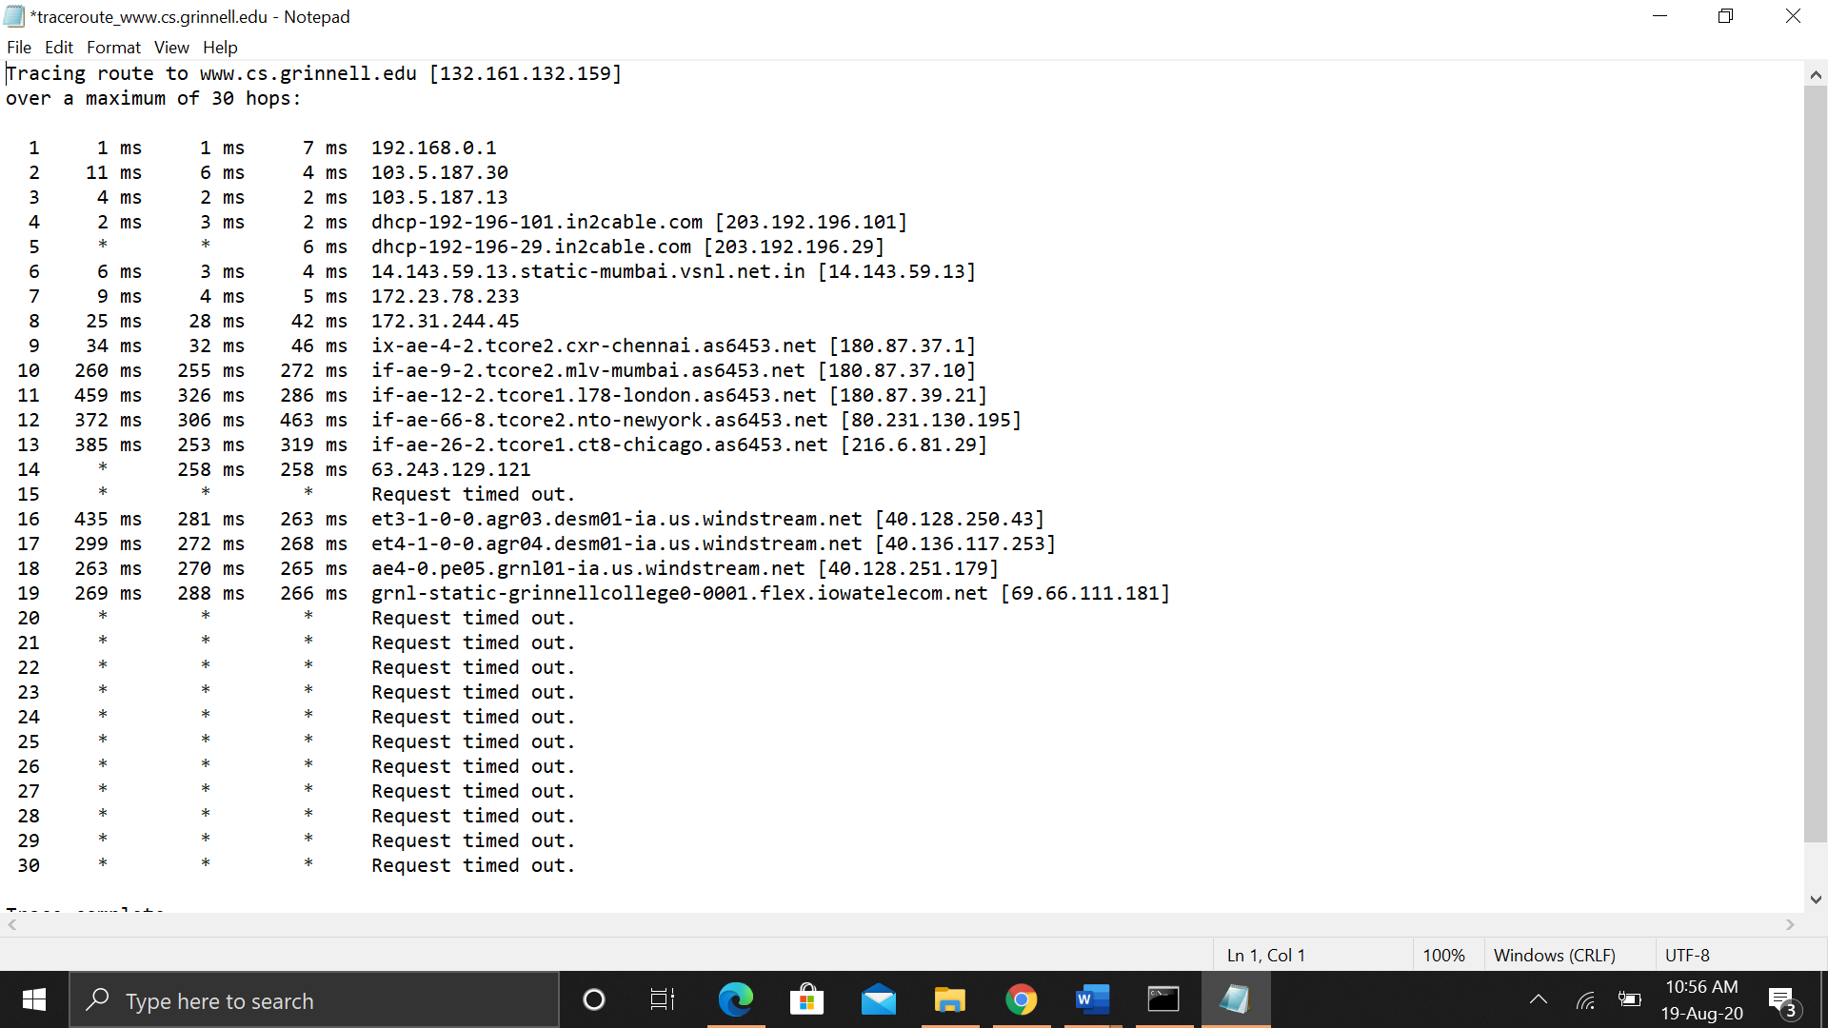

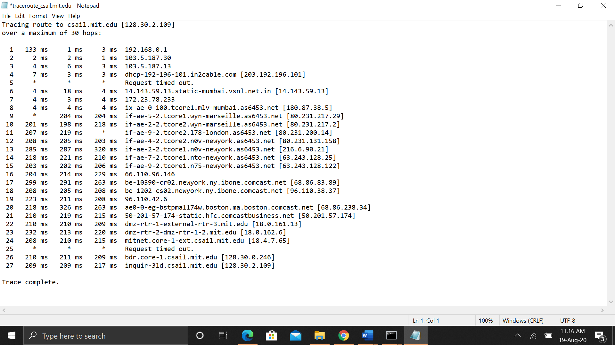

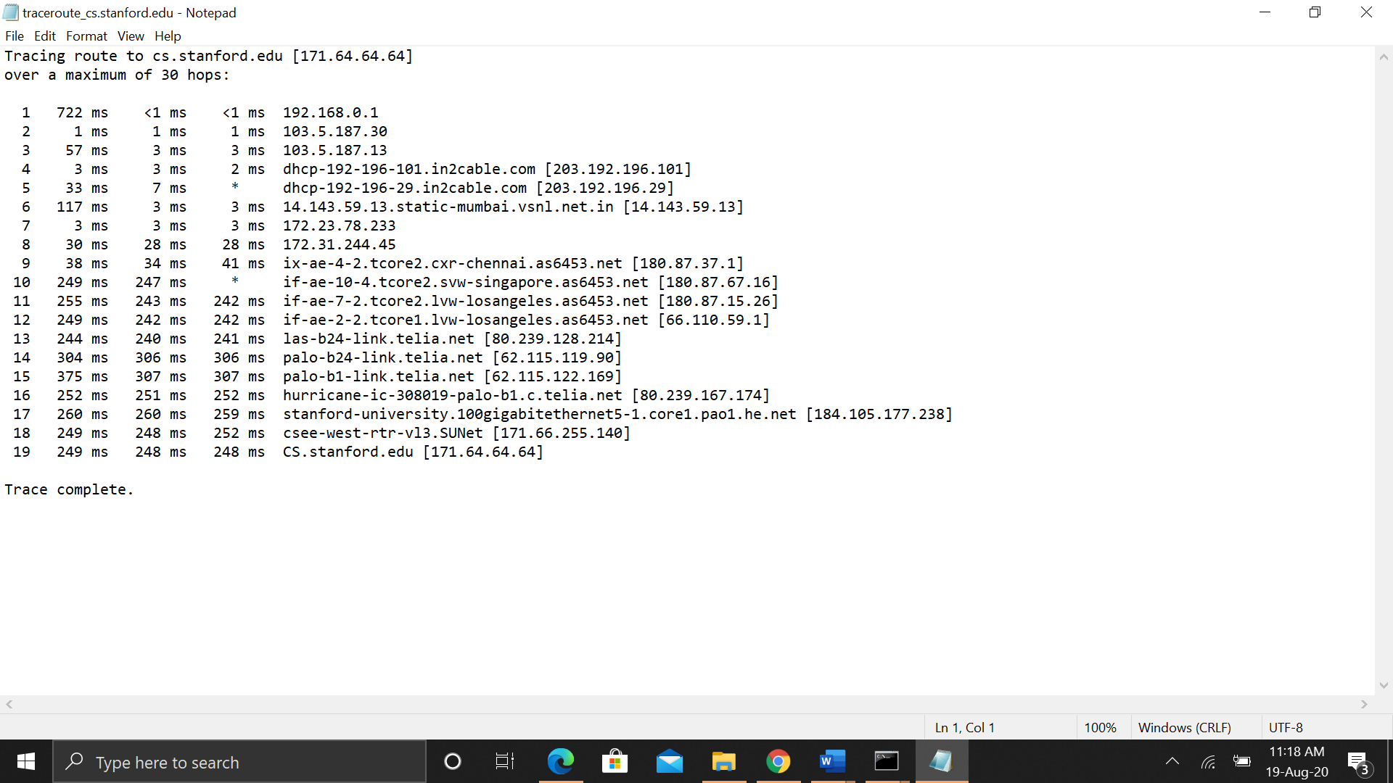

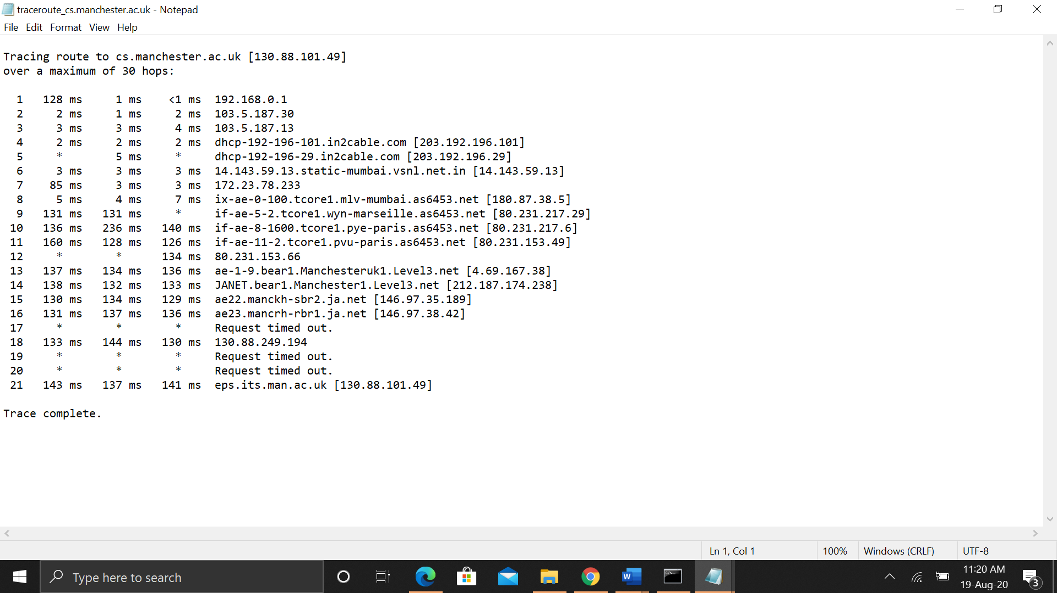

Exercise 2: (Very short.) Use traceroute to trace the route from your computer to math.hws.edu and to www.hws.edu. Explain the difference in the results.

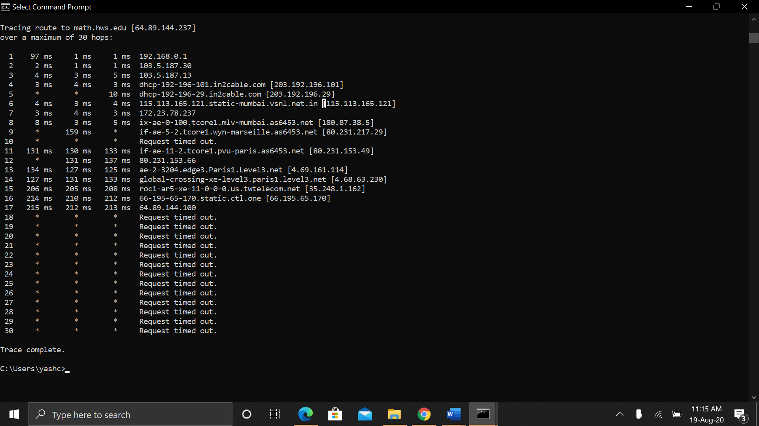

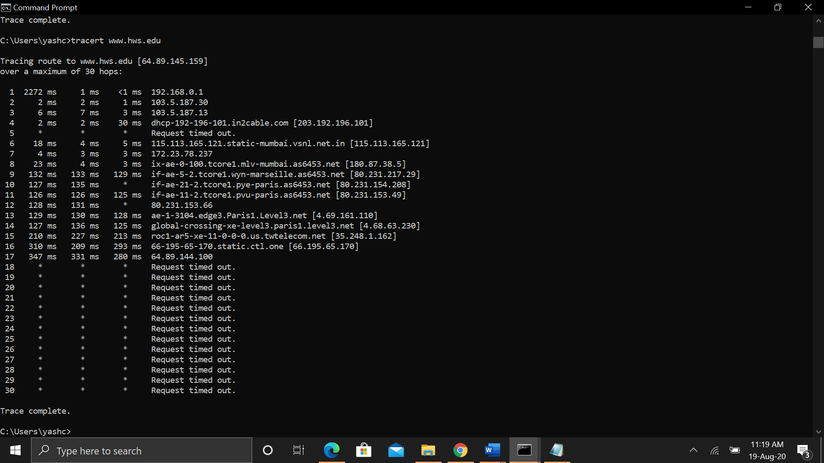

We can see that the hop number is the same for both the traceroutes, but RTT varies.

Exercise 3: Two packets sent from the same source to the same destination do not necessarily follow the same path through the net. Experiment with some sources that are fairly far away. Can you find cases where packets sent to the same destination follow different paths? How likely does it seem to be? What about when the packets are sent at very different times? Save some of the outputs from traceroute. (You can copy them from the Terminal window by highlighting and right-clicking, then paste into a text editor.) Come back sometime next week, try the same destinations again, and compare the results with the results from today. Report your observations.

Observed on 17th August

Observed on 20th August
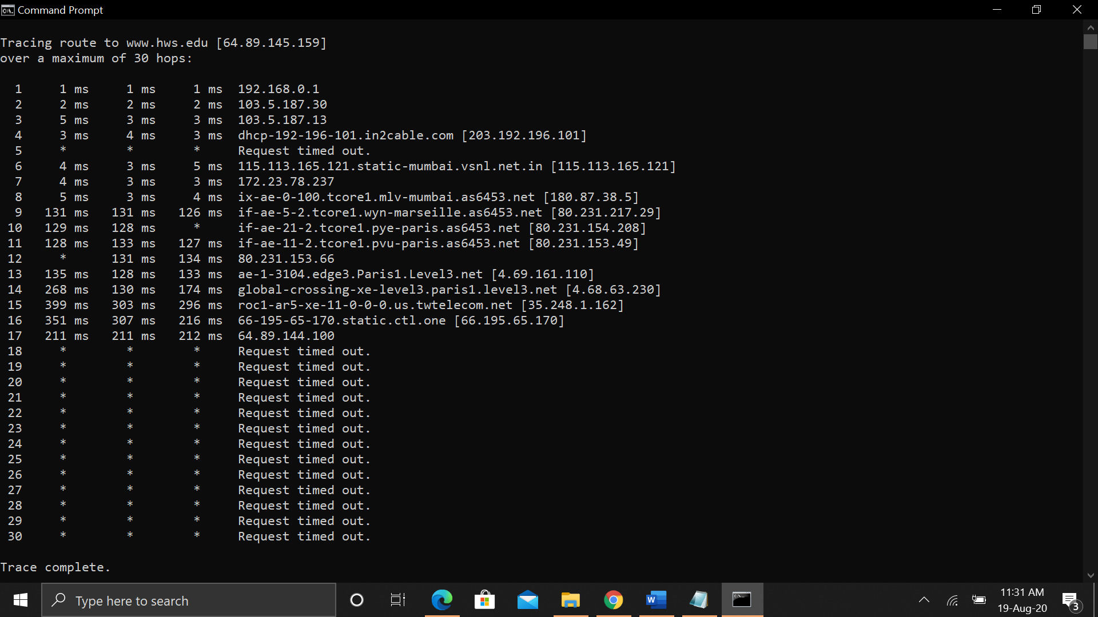

From the above screenshots, it can be seen that for same source and same destination, the packets sent at different times have different RTT and follow different paths.

Questions About Paths
Now look at the results you gathered and answer the following questions about the paths taken by your packets. Store your answers in a file named traceroute.txt.
- Is any part of the path common for all hosts you tracerouted?
Ans. Yes, the source IP address
- Is there a relationship between the number of nodes that show up in the traceroute and the location of the host? If so, what is this relationship?
Ans. There is no relation between the two.
- Is there a relationship between the number of nodes that show up in the traceroute and latency of the host (from your ping results above)? Does the same relationship hold for all hosts?
Ans. There is a direct relationship between the number of nodes and the latency of the host.

Whois — The whois command can give detailed information about domain names and IP addresses. If it is not installed on the computers then install it with command sudo apt-get install whois in. Whois can tell you what organization owns or is responsible for the name or address and where to contact them. It often includes a list of domain name servers for the organization.

When using whois to look up a domain name, use the simple two-part network name, not an individual computer name (for example, whois spit.ac.in).

Exercise 4: (Short.) Use whois to investigate a well-known web site such as google.com or amazon.com, and write a couple of sentences about what you find out.

Exercise 5: (Should be short.) Because of NAT, the domain name spit.ac.in has a different IP address outside of SPIT than it does on campus. Using information in this lab and working on a home computer, find the outside IP address for spit.ac.in. Explain how you did it.

Geolocation — A geolocation service tries to tell, approximately, where a given IP address is located physically. They can't be completely accurate—but they probably get at least the country right most of the time.

This geolocation program is not installed on our computers, but you can access one on the command line using the curl command, which can send HTTP requests and display the response. The following command uses curl to contact a public web service that will look up an IP address for you: curl ipinfo.io/<IP-address>. For a specific example:

curl ipinfo.io/129.64.99.200

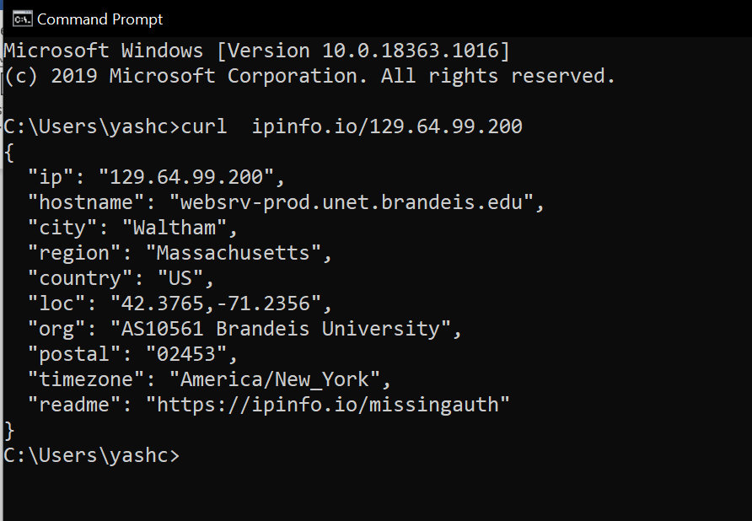

(As you can see, you get back more than just the location.)

Exercise 6: Find a few IP addresses that are connected to the web server on spit.ac.in right now, and determine where those IP addresses are located. (I'm expecting that there will be several; if not, try again in a few minutes or sometime later.) Find one that is far from Geneva, NY. Explain how you did it.

References:
- https://en.wikipedia.org/wiki/Traceroute
- http://docs.netapp.com/ontap-9/topic/com.netapp.doc.dot-cm-cmpr-940/network__traceroute.html#:~:text=The%20network%20traceroute%20command%20performs,logical%20interface%20and%20its%20Vserver.
- https://www.cloudflare.com/learning/cdn/glossary/round-trip-time-rtt/#:~:text=What%20are%20common%20factors%20that,factors%20that%20can%20affect%20RTT.

